Name:  Class: | ____________________________________  ________________ | Date:_________
 | Year 8 Mathematics 2019  / 5  Investigation #1 – Part 1  Perimeter and Area  Resources Allowed: Personal notebook/ calculator/ graph paper/ ruler  Time allowed: 1 full class lesson and take home what is not completed

In this investigation you are tasked with designing a new Australian rules football playing field. The umpires are getting frustrated with the current designs because there are no fixed dimensions meaning that no two fields are the same. The fields are typically between 135 -185 metres long goal-to-goal and 110-155 metres wide wing-to-wing. The grounds can vary from long and narrow to almost circular, and are not necessarily symmetrical, depending upon how and where the field was constructed.
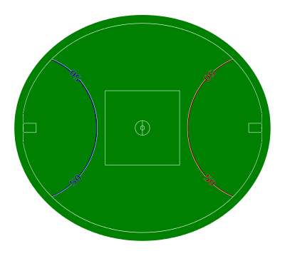
50 metre line
Goal area
Boundary Lines
Inner centre
Outer centre
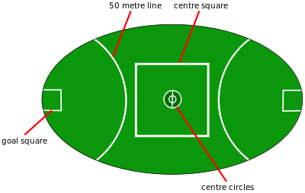

Question 1: Field Design

Design your new playing field on a separate piece of paper.
Your new design must include the following:

- The boundary must be a rectangle with a total area of between 15,000-25,000 m²
- At least three of the following shapes:
    - Triangle
    - Parallelogram
    - Trapezium
    - Kite
- No curved lines or circles
- ‘Inner’ Centre area for the bounce down with an area between 100-300 m²
- ‘Outer’ Centre area where the midfielders stand with an area between 1,000 and 3,000 m²
- A set of goal posts and 50 m line at each end of the field
- With a goal area directly in front with an area between 200 and 400 m²

Make sure all of the dimensions are labelled clearly
Question 2: Area

Find the area of each shape on your field design.
Keep your working out neat and organized and use appropriate units.

Question 2: Line markings

How much would it cost to paint all the lines on your field if painting each meter cost $0.45?

